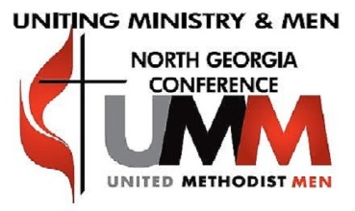
September 30, 2020
MEMORANDUM FOR RECORD
SUBJECT: UMM THIRD QUARTER REPORT (Secretary)
1. PURPOSE: The purpose of this report is to provide the Executive Committee a summary of the activities that occurred in the Conference during the 3rd Quarter 2020.
2. The information listed below gives an overview of actions or activities which occurred during the quarter and may be of interest to you:
- We kicked off our Administrative Year on 1 July, with a slate of officers ready to move our organization to the next level.
- On 22 July 2020, Immediate Past-President Louis Johnson installed our new leadership team, to its new role, using John Wesley’s “Covenant Service” piece as his backdrop.
- During this quarter, the communication strategy has been enhanced by the upgrading of the website and an increase use of social media. Thanks to the efforts of Ike Moore and Josh Washington.
- There was a smooth transfer of responsibilities as we had a change of leadership at our Treasurer’s position. The administration of the finances Eric Owen’s ministry is no longer a responsibility of our Treasurer. The members of the leadership team are encouraged to be sustained givers to our organization. A push has been made to all the Fellowships in the Conference to give to the organization on a reoccurring basis. The organization has no financial problems at the moment.
- For the first time in history, we participated in the Annual Conference via virtual means. All went well, and we accomplished all of the requirements in one day, instead of the 3-4 days in the past.
- The Executive and Retreat Committees have met monthly during the quarterly, using Zoom. All has gone well.
- Our organization has transitioned from a 12 District configuration to an 8 District formation. Meetings were planned with each of the 8 District to help facilitate that there was a viable District leadership structure in place.
- During the quarter, Jack Williams, with the help of Trey Brush and Kevin Harris gave some insights and “how to’s” on “Radical Mentoring”. Programs have already begun in the Conference. Thanks to Jack for his great leadership in this ministry.
- The Scouting Ministry, under the leadership of Chris Karabinos, continues its great work. The transition from 12 Districts to 8 Districts was done without a glitch, and all teams are in place
UMM Third Quarter Report (Secretary) September 30, 2020
Page Two
and operating smoothly. Updated information about scouting and calendars of events are all on the website. The Bishop’s Scout Lunch is already scheduled for October 2021.
- Minutes of the monthly meetings of the Executive Committee are posted on the UMM Conference website.
- During our September 2020 Executive Committee Meeting, Bishop Sue visited our monthly meeting.
- The Committee continues its planning and preparation for its Igniting Faith Summit on 16 and 17 October 2020.
Report Prayerfully Submitted,

John C. Holley Secretary NGCUMM

